Postal Life Insurance

Department of Post

Software Requirements Specification (SRS)/ Functional Requirements Specification (FRS)
  - Payment Gateway

INTERNAL APPROVAL FORM

Project Name: Payment Gateway
Version: 1.0
Submitted on:
 | Name | Date
Approved By:
Reviewed By:
Prepared By:

VERSION CONTROL LOG
Version | Date | Prepared By | Remarks
1

Table of Contents

1. Executive Summary 4
2. Project Scope 4
3. Business Requirements 4
4. Functional Requirements Specification 4
4.1 Pay Premium page 6
4.2 Payment Gateway Page 6
4.3 Payment Confirmation page 6
4.4 Auto-Debit Setup page 6
4.5 Notifications Page 7
5. Attachments 7

1. Executive Summary
This document outlines the requirement for integrating the UMANG mobile application with the Insurance Management System (IMS) of India Post PLI/RPLI. The integration aims to provide seamless digital access to insurance services for customers via UMANG.

2. Project Scope
This scope will include the integration of Insurance Management System with UMANG Application.

3. Business Requirements

ID | Functionality | Requirements
FS_PG_001 | Multi-Gateway Support | Integrate multiple gateways for redundancy and choice.
FS_PG_002 | POSB Integration | Allow direct debit from POSB accounts via portal.
FS_PG_003 | Auto-Debit Setup | Enable e-NACH/Standing Instructions for recurring payments.
FS_PG_004 | Payment Modes | Support UPI, Net Banking, Debit/Credit Cards, Wallets.
FS_PG_005 | Premium Payment | Allow customers to pay renewal/advance premiums.
FS_PG_006 | Loan Repayment | Enable loan repayment via gateway.
FS_PG_007 | Revival Payment | Allow revival of lapsed policies through payment gateway.
FS_PG_008 | Real-Time Updates | Sync payment status with IMS and accounting systems instantly.
FS_PG_009 | Notifications | Send SMS/email alerts for success/failure of transactions.
FS_PG_010 | Receipt Generation | Provide downloadable receipts post-payment.
FS_PG_011 | Transaction Dashboard | Show transaction history, refunds, and status to users.
FS_PG_012 | Admin Reporting | Provide reconciliation reports, failure analytics, audit trail.
FS_PG_013 | Security Compliance | Ensure PCI-DSS, RBI, MeitY compliance for digital payments.
FS_PG_014 | Retry Mechanism | Allow retry for failed transactions with proper logging.
FS_PG_015 | Refund Handling | Enable refund initiation and tracking via portal.

4. Functional Requirements Specification

Use Case Diagram for Payment Gateway Integration with IMS: 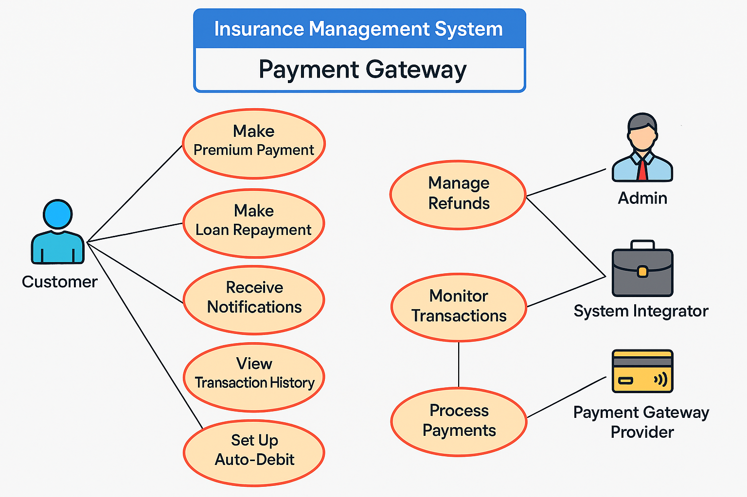
Wireframe for the Payment Gateway Pages:
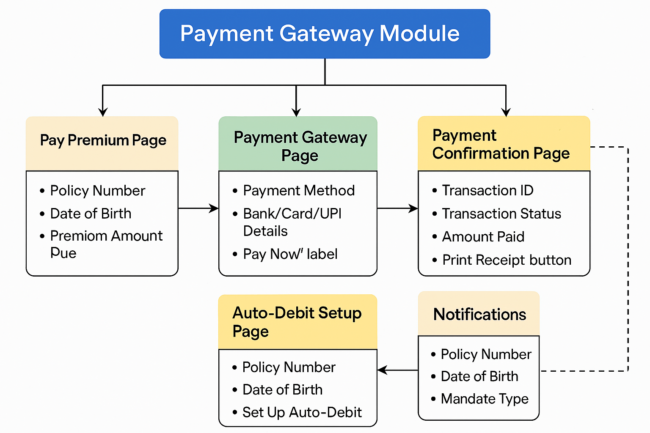

4.1 Pay Premium page
- Purpose: To allow customers to initiate premium payment by fetching policy details and premium due amount.

- Fields:
  - Policy Number: Text: Unique identifier of the policy
  - Date of Birth: Date: Mandatory
  - Premium Amount Due: Auto-populated from backend

4.2 Payment Gateway Page
- Purpose: To capture payment details and redirect to selected payment gateway.

- Fields:
  - Payment Method: Dropdown: Options are Debit Card, Credit Card, Net Banking, UPI, Wallet.
  - Bank/Card/UPI Details: Text: Based on selected method (e.g., card number length, UPI ID format)
  - Pay Now Button: Button: Initiates payment request to gateway

4.3 Payment Confirmation page
- Purpose: To display transaction status and provide receipt download option.

- Fields:
  - Transaction ID: Read-only: Auto-generated by gateway
  - Transaction Status: Text: Values are Success, Failed, Pending
  - Amount Paid: Read-only Text
  - Print Receipt Button: Button: Generates PDF receipt

4.4 Auto-Debit Setup page
- Purpose: To enable customers to set up recurring premium payments via e-NACH or standing instructions.

- Fields:
  - Policy Number: Text: Unique identifier for the policy
  - Date of Birth: Date of Birth for Insured
  - Mandate Setup Details: Form Section: Includes Bank Account Number, IFSC Code, Consent Checkbox
  - Submit: Button: Initiates mandate registration

4.5 Notifications Page
- Purpose: To configure and send alerts for payment success/failure and mandate updates.

- Fields:
  - Policy Number: Text: Unique identifier for the policy
  - Date of Birth: Date of Birth for Insured
  - Mandate Type: Options include SMS, Email, Both
  - Notification Message: Text: Auto-generated template

5. Attachments
The following documents can be referred.

